**Soal 1 : The Report**

**Link hakerank:** [https://www.hackerrank.com/challenges/the-report/problem?isFullScreen=tru](https://www.hackerrank.com/challenges/the-report/problem?isFullScreen=true)

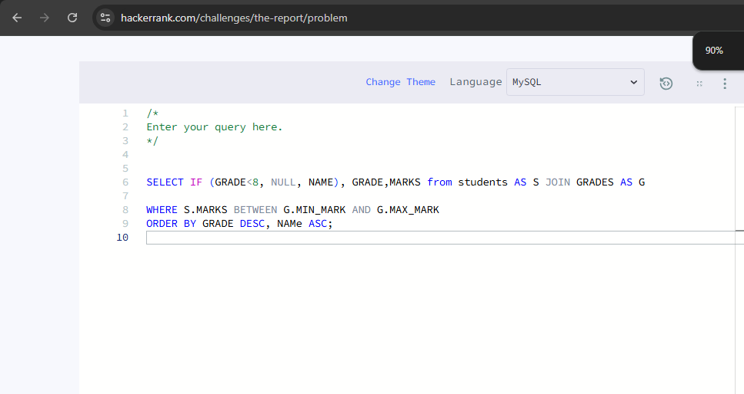

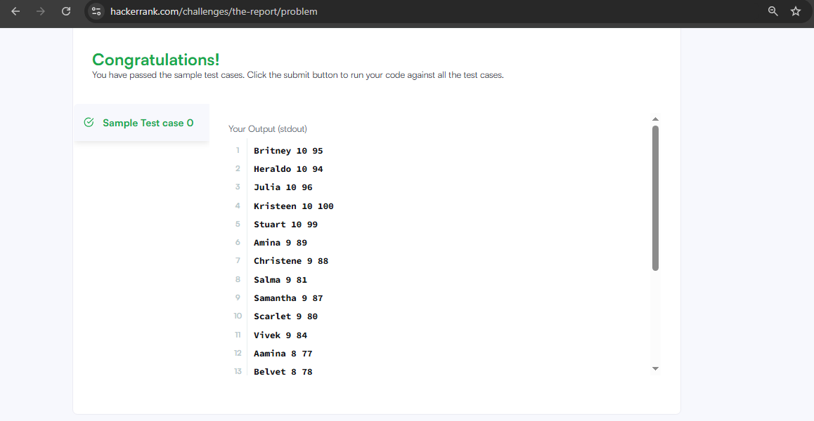

**Soal 2 : Weather Observation Station 18**

**Link hakerank:** <https://www.hackerrank.com/challenges/weather-observation-station-18/problem?isFullScreen=true>

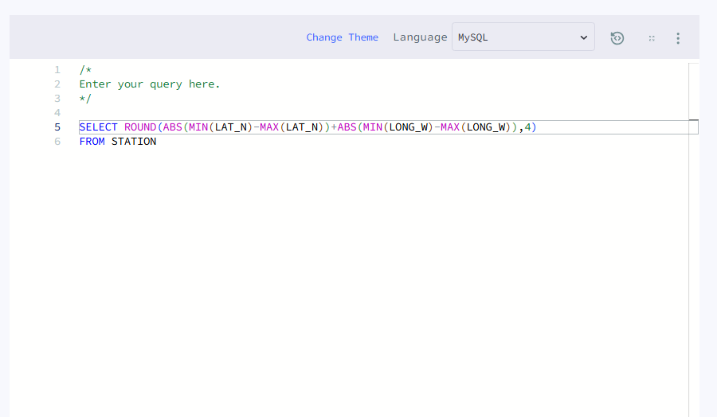

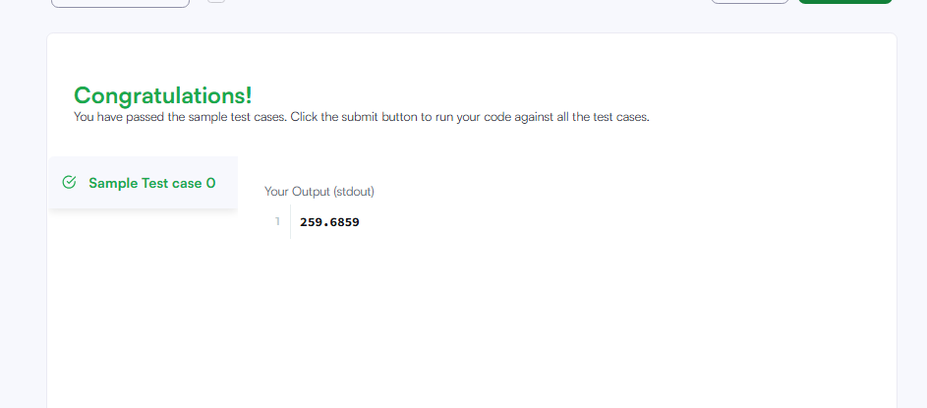

**Soal 3 : Top Competitors**

**Link hakerank**

<https://www.hackerrank.com/challenges/full-score/problem?isFullScreen=true>

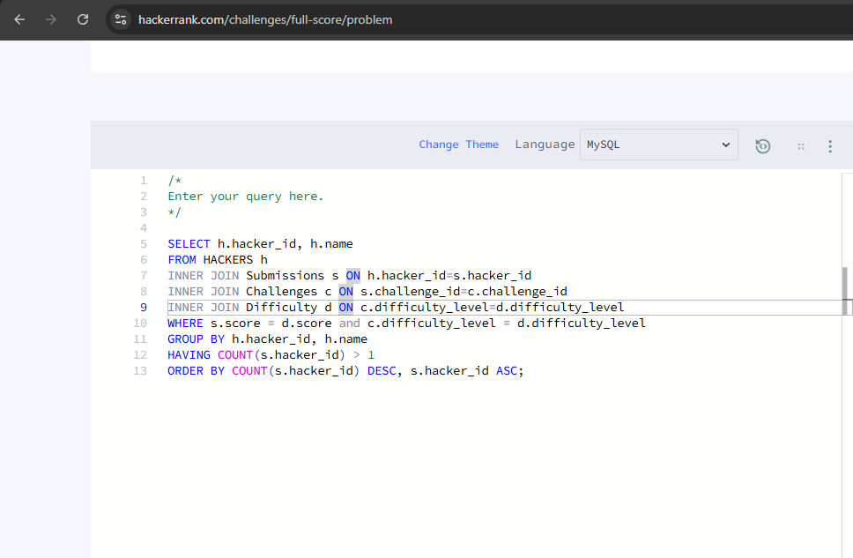

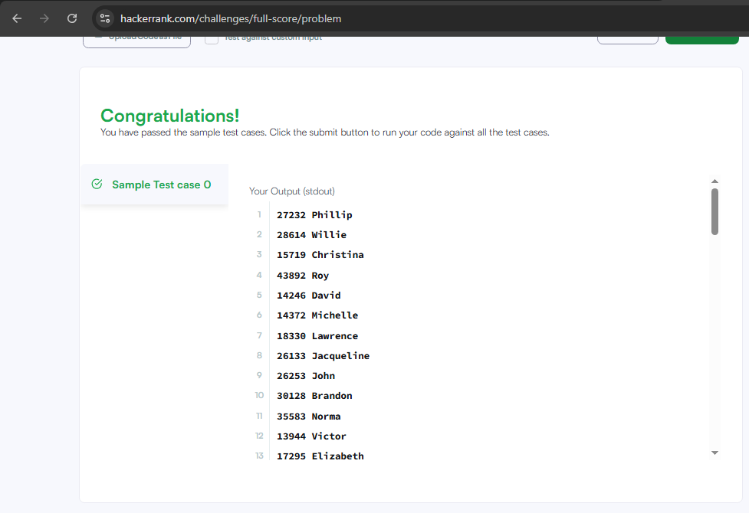

**Soal 4 : Ollivander's Inventory**

**Link soal:** <https://www.hackerrank.com/challenges/harry-potter-and-wands/problem?isFullScreen=true>